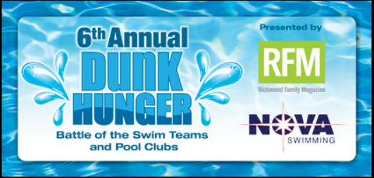

2017 Dunk Hunger - Jump in with both feet!

The sixth annual Dunk Hunger food drive launches this month at pools all over Richmond and runs through August 31st. It is sponsored by Richmond Family Magazine and NOVA of Virginia Aquatics and benefits FeedMore's Central Virginia Food Bank.

For thousands of local families, summer brings fun in the pool - while for thousands of others, the same season brings the challenge of obtaining enough food to eat. As many participating pools from all over Richmond know, Dunk Hunger is a rewarding way to do good as a family and as a community. And unlike cancer or other diseases that devastate so many families, chronic hunger is something we can fix!

Join us as we Dunk Hunger - a community effort to end chronic hunger in central Virginia. The pool that collects and delivers the most donations to FeedMore and raises the most funding by August 31, will receive a $1,000 cash prize!

Remember, working with RFM to Dunk Hunger is a great way to help your kids get service hours that are required by some area schools. Many families make signs and sponsor contests to boost donations at their local pools. And someone will have to deliver all those food donations to the convenient drop-site at FeedMore. (A great assignment and more service hours for your new teen driver!)

Donation bins/boxes will be provided at the pool. The online donation link for our pool can be found at https://feedmore.org/dunkhunger.

Contact Carey Andrews at social@glenallenpool.com with questions. (unless you want to add me to Lynda's community outreach e-mail).

